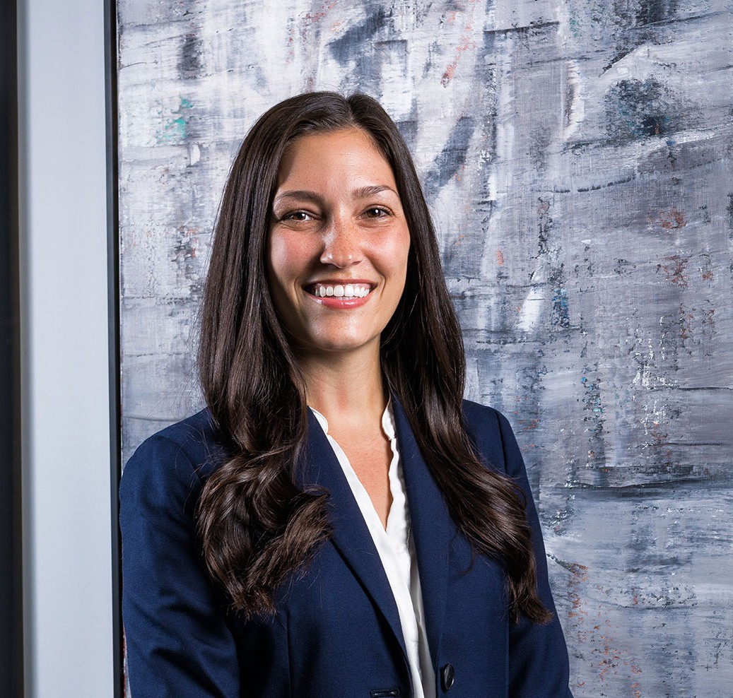

LYNDSEY MAASCH
Associate
Business Litigation

Phoenix
P: 602.916.5401 F: 602.916.5601
lmaasch@fennemorelaw.com
LYNDSEY MAASCH
Lyndsey Maasch is an Associate in Fennemore’s Business Litigation practice group in Phoenix. She represents businesses, business owners, and professionals in complex commercial disputes.
Her practice includes contract disputes, restrictive covenant matters, insurance coverage
disputes, and appeals. She represents clients on both sides and through all stages of a dispute, from early strategy and pre-suit resolution through dispositive motions, evidentiary hearings, trial, and appeal.
Lyndsey particularly enjoys matters that require digging into a complicated factual record, understanding how a client’s business actually works, and finding the clearest path through a difficult problem. She takes pride in mastering the details without losing sight of the client’s broader business objectives.
Outside the office, Lyndsey is a dedicated member of the Auxiliary Board of Fresh Start Women’s Foundation, where she supports the organization’s mission of empowering women to succeed. When she’s not working, you can find Lyndsey at a local coffee shop with her husband, Jeff, or chasing her daughters, Tatum and Baker, around the zoo or the aquarium.

EDUCATION

J.D., magna cum laude, Arizona State University, Sandra Day O’Connor College of Law B.A., Political Science and Legal Studies, University of Wisconsin-Madison

AREAS OF PRACTICE

Business Litigation Health Care Automotive Dealership

AWARDS AND HONORS

Best Lawyers in America®, Ones to Watch, Commercial Litigation (2027) Health Care Law (2026-2027)

REPRESENTATIVE MATTERS

Obtained reversal from the Arizona Court of Appeals of summary judgment entered against homeowner clients in a construction defect dispute. Duncan v. LaBlonde Development Corp., No. 1 CA-CV 24-0715, 2025 WL 1882825 (Ariz. Ct. App. July 8, 2025).
Represented a business client in a California tax appeal that resulted in a refund of more than
$220,000 after the California Franchise Tax Board reversed its position on a late payment penalty.
Second-chaired a preliminary injunction evidentiary hearing in a physician departure and restrictive covenant dispute on behalf of an oncology practice.
Third-chaired a preliminary injunction evidentiary hearing in a physician restrictive covenant dispute, resulting in injunctive relief protecting a healthcare client’s confidential information.
Obtained summary judgment on all claims against a construction client and recovered nearly all of the client’s attorneys’ fees and costs after taking the lead on dispositive briefing and oral
argument.
Third-chaired a six-day jury trial in a complex commercial contract and implied covenant dispute involving an aircraft engine maintenance program.
Successfully represented then-Governor Doug Ducey and the Arizona Department of Economic Security in litigation challenging Arizona’s termination of participation in federal pandemic
unemployment benefit programs, securing affirmance on appeal. Unemployed Workers United
v. Ducey, 254 Ariz. 95 (App. 2022).

ARTICLES AND PRESENTATIONS

Co-Author, “Seven Significant Differences Between Arizona and Federal Civil Procedure in 2024,” Fennemore Blog, June 20, 2024
Co-author, “OSHA Issues Emergency Temporary Standard for Health Care Employers,” Fennemore Client Alert, July 8, 2021

PROFESSIONAL AND COMMUNITY AFFILIATIONS

Member, Auxiliary Board, Fresh Start Women’s Foundation

ADMISSIONS

Arizona
U.S. District Court, District of Arizona
U.S. Court of Appeals, Federal Circuit

