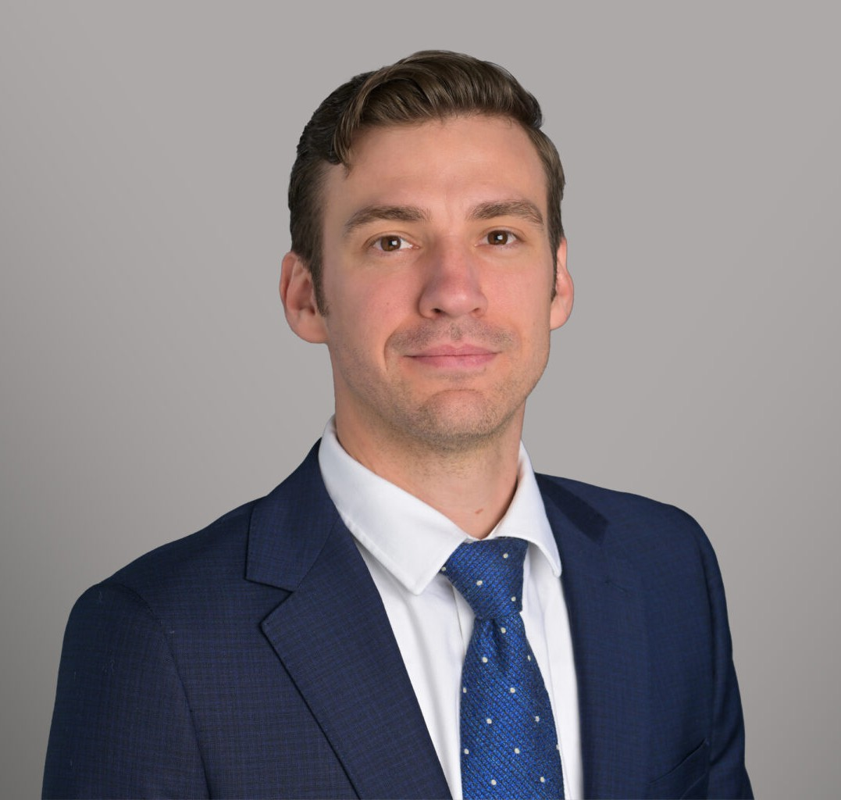

MAXIMILLIAN J. PASOWICZ
Associate
Business Litigation

Denver
P: 303.529.0947
mpasowicz@fennemorelaw.com

MAXIMILLIAN J. PASOWICZ
Maximillian Pasowicz is a Colorado attorney who counsels and represents clients across all aspects of their business operations. His practice includes drafting and negotiating contracts, guiding clients through regulatory compliance and entity formation, and litigating disputes involving non-payment, construction defect defense, and complex business conflicts such as intentional torts, Colorado Uniform Commercial Code, Colorado Consumer Protection Act, and Colorado Mechanics’ lien laws. Max combines his legal training with hands-on construction experience to deliver practical, solutions-focused representation for contractors, subcontractors, and other businesses throughout Colorado.
Before earning his J.D. from Vermont Law School in 2021, Max gained valuable legal experience as a law clerk in private practice, with a contract public defender, and with the Washington County State’s Attorney’s Office in Barre, Vermont. His diverse training gave him a broad base of practical skills in both transactional and litigation matters.

EDUCATION

J.D., Vermont Law School, 2021 Metropolitan State University of Denver, 2017

AREAS OF PRACTICE

Business Litigation Construction Law

AWARDS AND HONORS

Best Lawyers: Ones to Watch® in America, Construction Law, 2027

REPRESENTATIVE MATTERS

Represented a mid-market general contractor through jury trial resulting in a favorable verdict

Represented an individual homeowner through trial resulting in a favorable verdict

ARTICLES AND PRESENTATIONS

“Small Contractors Business Checklist: 10 Things Your Business Needs to Know to Protect Itself from Liability in an Increasingly Complex Marketplace” Tradecraft Industries, August 2022
“Choose Foresight Not Hindsight: What Every Contractor Needs to Know in 2022” Tradecraft Industries, February 2022

PROFESSIONAL AND COMMUNITY ACTIVITIES

Colorado Contractors Association Colorado Bar Association
Denver Bar Association

ADMISSIONS

Colorado

