
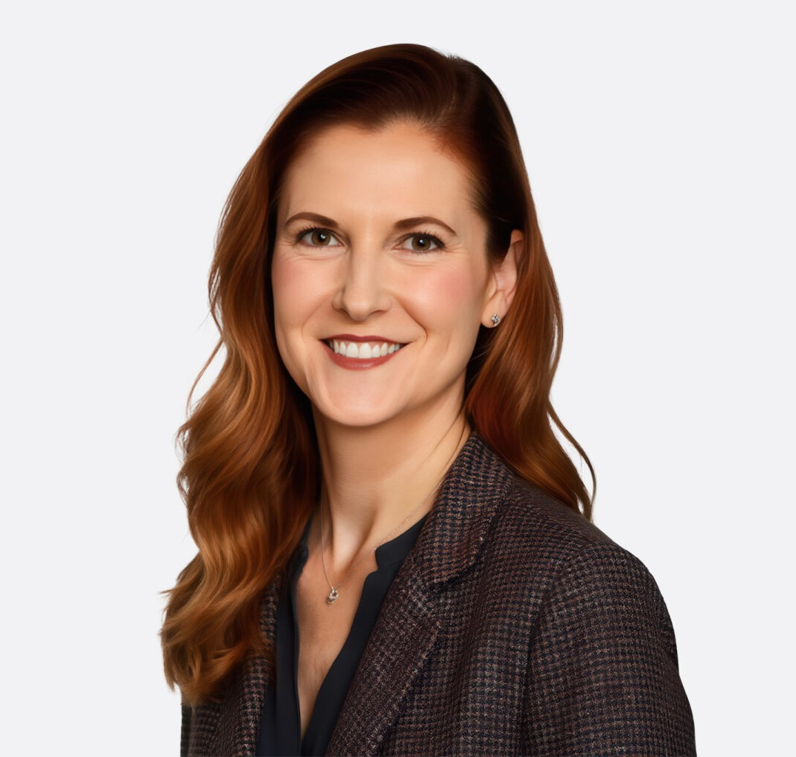
Andrea Marconi is an experienced complex commercial litigator and serves as Chair of the firm’s business litigation practice group. Her broad spectrum of work encompasses many areas, including both representing and litigating cases against public entities and regulatory agencies, high value tort matters, insurance coverage and indemnity matters, and financial services issues such as payment processing, credit card processing, and ACH transactions. In addition, Andrea has significant experience representing entities throughout the healthcare industry, including representing health insurers, providers, and medical billing companies in numerous matters such as coverage issues, regulatory and compliance matters, ERISA claims, and defense of bad faith claims. Routinely arbitrating and contesting cases in state and federal courts around the
ANDREA L. MARCONI
Director
Business Litigation
Phoenix
P: 602.916.5335 F: 602.916.5535
amarconi@fennemorelaw.com
“
The question isn't who is going to let me; it's who is going to stop me.
-Ayn Rand
ANDREA L. MARCONI
”
country, she also has extensive experience litigating a wide array of real estate contract
disputes, public entity immunity issues, franchise litigation, restrictive covenants, and trade secret litigation.
Although she did not come from a family of attorneys, Andrea knew early on that her calling was to be an attorney. She has always loved analyzing problems, persuading others as to her opinion on the facts and arguing with her father — and often winning — at the kitchen table. As a business litigation attorney, she now advises a diverse group of clients, including individuals, small and mid-sized businesses, and Fortune 500 companies.
She litigates disputes from start to finish — and often resolves these cases before they need to be addressed in the courthouse. She continues to study the art and science of disagreements, and how to best solve them, which is often conducive to long-term relationships with her clients. She frequently takes the role of outside general counsel, looking at ways of avoiding ambiguity that could lead to costly disputes in the future. While not afraid to fight when necessary, Andrea’s approach throughout her career has been to learn her clients’ business inside and out,

understanding critical issues and proactively handling any problems in an efficient and cost-effective manner.
When not litigating, Andrea is probably volunteering in the community. Her passion for animal welfare is showcased in her efforts as the past chair and longtime member of the Arizona Humane Society’s board of directors. Andrea is also Chair-elect and a member of the Chandler Chamber of Commerce Board of Directors and involved in volunteering with ICAN – an award-winning and nationally recognized youth development program. She is also a member of the national Board of Directors for the Federal Bar Association and a national leader with the FBA’s Federal Litigation Section.
Her two sons, Taylor and Brady, are her pride and joy, and her weekends are spent at their numerous sports and other events.

EDUCATION

J.D. Arizona State University, Sandra Day O’Connor College of Law B.A., Political Science, Sociology, University of Arizona
AREAS OF PRACTICE

OTHER EXPERIENCE

Litigation

Business Litigation Health Care
Real Estate Intellectual Property
Automotive Dealership

REPRESENTATIVE CASES

Represented the State of Arizona, Arizona Department of Transportation, in a more than four-year long litigation resulting from flooding that damaged properties in Southern Arizona, culminating in a 2-week trial after which the court found in favor of the State of Arizona on all claims and issues.
Represented the State of Arizona, Arizona Department of Transportation, in a 135-plaintiff mass action seeking 8 figures in damages resulting from flooding that occurred in Mesa, Arizona, along the U.S. 60 freeway. Following a hard fought and complex 3-week jury trial, we obtained a unanimous jury verdict on all of plaintiffs’ claims. The jury also unanimously found that we established the “State of the Art” affirmative defense, which would have barred any liability that otherwise might have been established.
Represent one of the largest and fastest growing national online vehicle sales and logistics companies in numerous matters, including contract and consumer-related disputes.
Represent one of the nation’s largest health insurers in various disputes, including commercial disputes, coverage actions, bad faith, ERISA claims, and regulatory matters.

Achieved early dismissal of large California pension plan in federal court litigation involving claim for benefits.
Prosecuted claims against contractor and negotiated favorable settlement in favor of the country’s second largest waste management company in slope failures case.
Achieved early dismissal through application of qualified immunity of public employee in a high-profile tort and personal injury case alleging negligence and breach of duty claims.
Represent military weapons systems manufacturer in trade secret misappropriation and patent claims case.
Represented a national franchisor of massage and spa clinics with franchises in 49 states, including serving as co-lead member of the franchisor’s national defense counsel team for various kinds of tort claims.
Defended and negotiated a favorable settlement of non-compete, trade secret misappropriation and unfair competition claims brought against a high-level sales employee after his departure from a prior employer.
Defended credit card processing company in numerous putative class action cases that were consolidated and transferred to a multi-district litigation involving claims arising out of one of the largest alleged pyramid and Ponzi schemes in U.S. history.
Achieved dismissal of payment gateway provider in same multi-district litigation involving claims arising out of one of the largest alleged pyramid and Ponzi schemes in U.S. history.
Representation of third-party payment processor as outside general counsel in numerous aspects of its business, including contract drafting and review, regulatory and compliance issues, employment matters, and litigation.
Represents clients in defending against vicarious liability and respondeat superior claims arising out of negligent and intentional conduct by employees, contractors, franchisees, and other like individuals or entities.
Defended large supplier of automated voice response systems in indemnification action arising out of patent infringement claims alleged against a call processing center to whom the client provided its product.
Represented a local fine dining restaurant group and was part of the team who negotiated a favorable settlement for client in actions involving claims of breach of a multi-million dollar promissory note against the financiers who purchased the restaurant group and defending
against trademark and trade dress infringement claims asserted by the purchaser against the restaurant group.
Represented a large solid waste company in arbitration regarding a success fee and royalty contract where the claimant contended it had earned a large success fee and multi-million dollar royalty in connection with a landfill expansion. After a full evidentiary hearing, the arbitrator ruled that the claimant had not established entitlement to either the success fee or royalty and issued an award in favor of the waste company. The claimant moved the Arizona
Superior Court to vacate the award. The court denied the motion to amend and confirmed the arbitration award.
Defended claims by a putative class of consumers alleging unlawful pharmaceutical pricing in multi- district litigation matter.
Represented a Japanese EPC subcontractor in arbitration of consolidated claims arising out of the construction of a 790-Megawatt Power Plant in the Midwestern United States.

Defended more than 30 individual personal injury claims alleging purported benzene exposure in a Midwestern community against one of the world’s largest oil companies related to one of the company’s refineries and achieved a successful settlement of all remaining claims.
Participated in negotiating a favorable settlement and business licensing agreement to resolve trade secret and misappropriation claims against a large industrial manufacturer client.

AWARDS AND HONORS
Best Lawyers in America®, Banking and Finance Law, 2022-2027
Best Lawyers in America®, Litigation – Real Estate, 2024-2027 Top Lawyer – Civil Law Litigation, Phoenix Magazine, 2026
Southwest Super Lawyers®, Business Litigation, 2019-2026 Most Influential Women in Arizona, AZ Big Media, 2023 Top Lawyers, Phoenix Magazine, 2025
Women Achievers of Arizona, Arizona Capitol Times, 2021
Southwest Super Lawyers®, Top 25 Women, State of Arizona
AZ Business Magazine, Top 100 Lawyers in Arizona
Southwest Super Lawyers®, Rising Star, 2014-2016
AV® Preeminent™ Peer Review Rated (the highest rating available), by Martindale-Hubbell

ARTICLES AND PRESENTATIONS

Co-Author, “Avoid the Fallout from a ‘Business Divorce’,” Greater Phoenix inBusiness Magazine, June 1, 2026
Co-Author, “How to Avoid a Contentious Business Divorce,” Wealth Management, April 29, 2026
Co-Author, “Clickwrap Agreements Are Binding Contracts,” Greater Phoenix InBusiness, January 2025
Co-Author, “Clickwrap agreements are binding contracts: key considerations for consumers and businesses,” Fennemore Blog, November 26, 2024
Co-Presenter, “AI Education & Workforce Seminar,” Chandler Chamber of Commerce, September 2024
Author, “What CRE Can Learn from the Shockwaves Sent through RRE,” Greater Phoenix InBusiness, July 2024
Author, “A Wake-Up Call for More Transparency in Commercial Real Estate Transactions — and 6 Takeaways,” Phoenix Business Journal, April 2024
Featured, “Most Influential Women in Arizona,” AZ Big Media, July 2023
Featured, “Meet the 2022 Women of Chandler,” Chandler City Lifestyle, May 2022
Interview, “Community Highlights: Meet Andrea Marconi of Fennemore Craig,” VoyagePhoenix, March 24, 2022

Author, “Beyond Boilerplate: Preparing the Right Dispute Resolution Clause for Business Contracts” AZ Attorney Magazine, November 2021
Co-Presenter, “Protecting Your Business and Brand,” KNOW Women National Summit, October 23, 2021
Co-author, “OSHA Issues Emergency Temporary Standard for Health Care Employers,” Fennemore Client Alert, July 8, 2021
Author, “What to Know: Updated OSHA COVID-19 Guidance for Workplaces,” Fennemore Client Alert, June 24, 2021
Author, “Contract Dispute Resolution Provisions Are Not One-Size-Fits-All,” InBusiness, May 1, 2021
Author, “COVID liability law protects a wide range of entities,” Ahwatukee Foothills News, April 26, 2021
Co-author, “Arizona Enacts COVID-19 Liability Protections for Health Professionals,” Fennemore Client Alert, April 22, 2021
Quoted, “What is covered by Gov. Ducey’s executive order on vaccine passports?” News 4 Tucson, April 22, 2021
Author, “Governor Ducey Bans “Vaccine Passports” for State and Local Governments,” Fennemore Client Alert, April 19, 2021
Author, “Arizona Enacts COVID-19 Liability Shield Law,” Fennemore Client Alert, April 14, 2021 Author, “Could Congress overturn Arizona’s right-to-work law?” AZ Big Media, March 8, 2021
Interview, “Andrea Marconi of Fennemore: ‘Focus on Yourself’,” Thrive Global, February 3, 2021
Interview, “Attorney Andrea Marconi of Fennemore: 5 Things I Wish Someone Had Told Me When I First Became an Attorney,” Authority Magazine, January 13, 2021
Presenter, “Top 5 Legal Tips to Protect Your Business and Brand,” KNOW Women Master Class, August 25, 2020
Author, “What Regulatory Actions Can Tell Payment Processors and ISOS About the Anticipated Wave of COVID-19 Related Enforcement and How to Protect Your Business,” Fennemore Client Alert, June 23, 2020
Author, “All Good Things Must Come to an End,” Fennemore Client Alert, April 28, 2020
Co-author, “COVID-19 and its Impact on the Deadline to Bring Legal Claims,” Fennemore Client Alert, April 28, 2020
Interview, “Women You Must Know and Do Business With,” The KNOW Book + Tribe, January 27, 2020
Author, “Spec’s Family Partners, Limited v. First Data Merchant Services,” Fennemore Client Alert, June 21, 2019
Co-author, “Vazquez v. Jan-Pro Franchising International, Inc.,” Fennemore Client Alert, May 28, 2019
Author, “Changes to the Administration of Commercial Litigation in Arizona: A Brief Overview of the Commercial Court Pilot Program”
Author, “Financial Institutions & Social Media: Final Guidance Issued By the FFIEC”
Author, “Facilitating Financial Transactions in the Age of Internet Gambling: Compliance with the Unlawful Internet Gambling Enforcement Act”

Author, “CFPB Announces Early Warning Notice of Enforcement Actions”
Author, “Betting and Buying: The Legality of Facilitating Financial Payments for Internet Gambling”
Author, “The Dodd-Frank Act and Consumer Financial Protection Bureau, What You Need to Know”
Presenter, “Emerging Issues: Social Media Guidelines for Banks and Financial Institutions Explored” Presenter, “Deconstructing a Litigation Budget”

PROFESSIONAL AND COMMUNITY ACTIVITIES

Chair-Elect, Chandler Chamber of Commerce Board, Ninth Circuit Lawyers Representative Federal Bar Association, National Board of Directors
Federal Bar Association, Federal Litigation Section, Board Member Federal Bar Association, National Sections and Divisions Council
Board of Directors, Phoenix Chapter of Federal Bar Association, Past President and Member Arizona Women Lawyer’s Association, Board of Directors
Arizona Humane Society Board of Directors, Chair
Board of Directors, Vice-Chair
Board of Directors, Governance Committee Chair
Co-Chair of Arizona Humane Society Signature Event, Compassion with Fashion Board of Directors, Member
Phoenix Suns Charities 88
Board of Directors (known as “The Big Gorillas”) Member
Member, Site Council for Curriculum Development, Knox Gifted Academy (Chandler) Board of Directors, Herberger Theater Center
Board Member, Women’s Metropolitan Arts Council

ADMISSIONS

Arizona
U.S. District Court District of Arizona
U.S. District Court District of Colorado
U.S. Court of Appeals Ninth Circuit

