
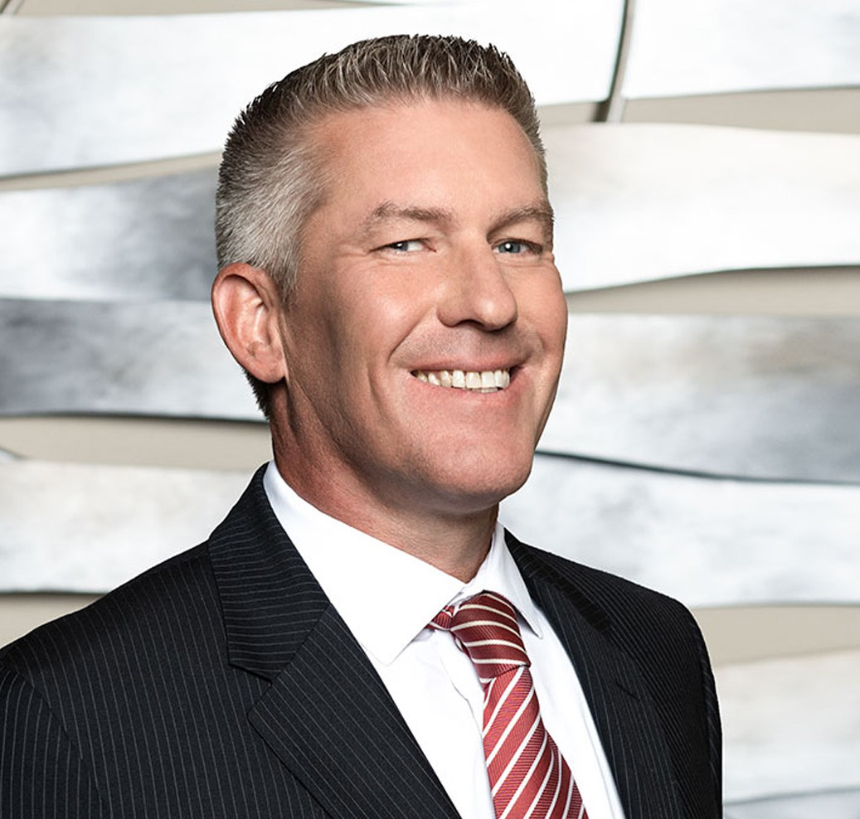
David Schneider specializes in litigation arising from complex business, shareholder and
DAVID D. SCHNEIDER
Director
Business Litigation
Fresno
P: 559.432.4500
F: 559.432.4590
dschneider@fennemorelaw.com
“
The harder you work, the luckier you get.
-Gary Player
DAVID D. SCHNEIDER
”
partnership disputes, real estate transactions and leases, and construction projects. In addition, David provides California Proposition 65 compliance counseling and vigorous defense representation to manufacturers, distributors, and retailers in a wide range of industries that are facing Proposition 65 issues, claims, and lawsuits.
David routinely handles civil disputes from a pre-litigation stage through arbitration and trial.
David’s pre-trial experience includes extensive law and motion drafting and courtroom advocacy, hundreds of depositions, and representing clients in scores of mediations that resulted in advantageous resolutions prior to trial.
David became a lawyer because he believes in the rule of law. His clients turn to him for assistance because he works tirelessly to help them achieve their objectives in a practical and efficient manner. David’s clients include large and small business owners in many industries, including agriculture, real estate, insurance, and construction.
David unplugs by coaching his kids’ baseball teams and spending time with his family and friends.

EDUCATION

J.D., San Joaquin College of Law
B.S., California State University, Fresno

AREAS OF PRACTICE

OTHER EXPERIENCE

Construction Litigation Real Estate Litigation
Business Litigation Apparel & Fashion

AWARDS AND HONORS
Best Lawyers in America®, Litigation – Real Estate, 2025-2027
Northern California Super Lawyers®, 2014-2023, 2025-2026

PROFESSIONAL AND COMMUNITY ACTIVITIES

Member, State Bar of California
Member, California Bar Association, Litigation Section
Member, Fresno County Bar Association, Real Property and Construction Law Sections
Past President, and current Member of Board of Governors, Association of Business Trial Lawyers, San Joaquin Valley Chapter

ADMISSIONS

California
U.S. District Court, Central District of California
U.S. District Court, Eastern District of California

