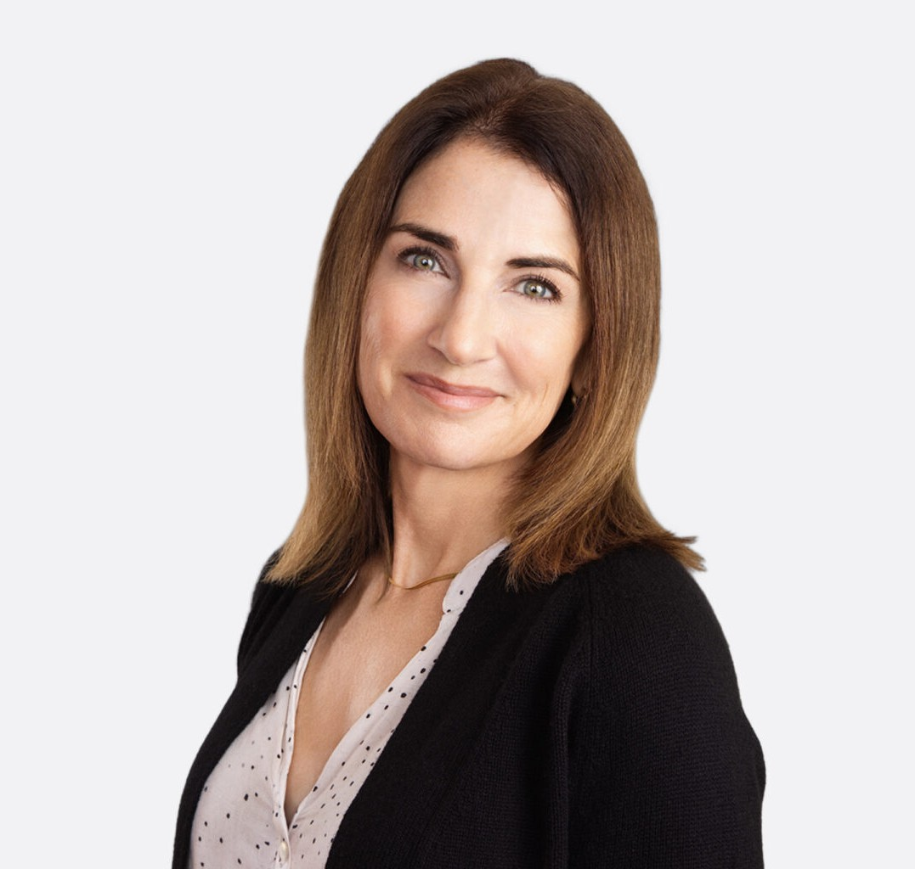

FRANCESCA K. BOYD
Director
Trusts & Estates

Oakland
P: 510.834.6600 F: 510.834.1928
fboyd@fennemorelaw.com

FRANCESCA K. BOYD
Francesca advises clients in all areas of estate planning, estate administrative law, wealth
management, and wealth transfer planning. She has experience in drafting complex wills and trust agreements, probating estates, administering trusts, analyzing estate and gift taxation
matters, and advising fiduciaries and beneficiaries. Representing corporate clients, Francesca has provided legal services on business formation and succession, charitable transfers and tax compliance.
Additionally, she served as Senior Project Manager of a real estate development company, overseeing design, entitlement, construction, and marketing, as well as managing outside legal counsel, financial advisors and lending institutions. In this role, she managed relationships with
investors, partners, city officials and the community. Francesca is also experienced in navigating California’s complex property tax rules governing change of ownership and reassessment of real estate.

EDUCATION

J.D., University of San Francisco, School of Law
M.A., California Institute of Integral Studies, Psychological Studies B.A., University of St. Thomas

AREAS OF PRACTICE

Trusts & Estates Tax Law
Estate Planning

ARTICLES AND PRESENTATIONS

Author, “Estate planning checkup: Are your estate and business succession plans aligned?,” San Francisco Business Times, May 1, 2026

Co-Author, “Estate planning checkup: ensuring estate and business succession plans align,” Orange County Register, April 30, 2026
Author, “Fennemore attorney Francesca Boyd with insights on preparing for upcoming trust and estate tax changes,” San Francisco Business Times, August 1, 2024
Author, “Understanding the Tax Implications of Real Property Joint Ownership Forms” CEB, Practitioner, 2023
Featuring, “Attorney Francesca Boyd on estate planning, advice for wealth transfer,” San Francisco Business Times, April 17, 2023
Interview, “Take One Day at a Time and Trust Yourself To Make the Right Decision In The Moment,” Fennemore Blog, September 15, 2022
Author, “Intentionally Defective Grantor Trust: Income Tax Issues,” Wendel Rosen LLP, October 21, 2021

PROFESSIONAL AND COMMUNITY ACTIVITIES

Member, California Lawyer’s Association
President, East Bay Trusts and Estates Lawyers Member, California State Bar

ADMISSIONS

California

