
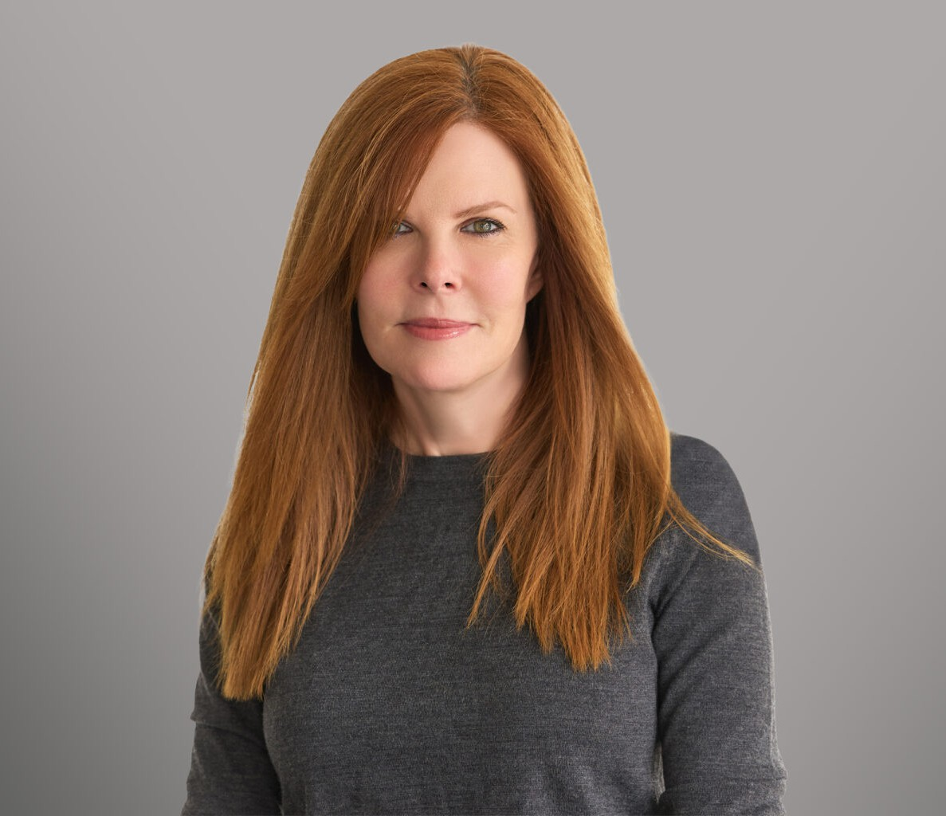
GAMBLE PARKS
GAMBLE PARKS
Director
Trusts & Estates
Santa Barbara
P: 805.420.6002 F: 805.420.6001
gparks@fennemorelaw.com
“
If you bungle raising your children, I don't think whatever else you do well matters very much.
Jacqueline Kennedy
”
Gamble Parks is a director in the firm’s Trusts & Estates practice group who works out of our Santa Barbara office. She creates innovative estate planning solutions and ensures her clients seamlessly navigate the often-complex process of estate planning and administration.
Originally from North Carolina, Gamble’s extensive experience and Southern charm equate to forming long-term relationships with her clients. As a certified specialist in estate planning, trust and probate law by the California Board of Legal Specialization, she draws on over two decades of substantive experience to assist high-net-worth individuals, families and fiduciaries in estate planning, trust and estate administration and contested matters, as well as property tax, charitable and business succession planning. Gamble takes great pride in her lasting relationships with her clients – and often their children and grandchildren – addressing their concerns in a tax efficient manner.
Gamble’s legal practice also includes work on corporate matters where she provides strategic, concierge legal services to entrepreneurs, high net worth individuals, family offices and their affiliated businesses. She advocates for her clients and works to solve problems as quickly, effectively and quietly as possible. A trusted counselor to her clients, she is also a board member of several Central Coast nonprofit and civic organizations, including Cottage Health System and the Music Academy of the West.
Outside of work, Gamble can often be found on the tennis court or the golf course. A world traveler, ask Gamble about her trek to the base camp of Mount Everest.

EDUCATION

J.D., Washington and Lee University School of Law

B.A., Washington and Lee University

AREAS OF PRACTICE

Trusts & Estates Estate Planning

AWARDS AND HONORS

Top 50 Women in Business, Pacific Coast Business Times, 2021-2023

ARTICLES AND PRESENTATIONS

Featured, “MJ Women: She Means Business,” Montecito Journal Magazine, July 11, 2025
Author, “Essential Steps to Prepare for Effective Estate Planning,” Fennemore Blog, October 7, 2024
Featured, “Fennemore law welcomes Gamble Parks to firm; expands services in Santa Barbara,” edhat Santa Barbara, July 19, 2023
Featured, “Gamble Parks Recognized as a 2023 Top Woman in Business,” Pacific Coast Business Times
Featured, “Gamble Parks Recognized as a 2022 Top Woman in Business,” Pacific Coast Business Times
Featured, “Gamble Parks Recognized as a 2021 Top Woman in Business,” Pacific Coast Business Times
Featured, “Trusts & Estates Attorney Gamble T. Parks Joins Brownstein”

PROFESSIONAL AND COMMUNITY ACTIVITIES

Past Board Member, Cottage Health
Past Board Member, Music Academy of the West

ADMISSIONS

California North Carolina

