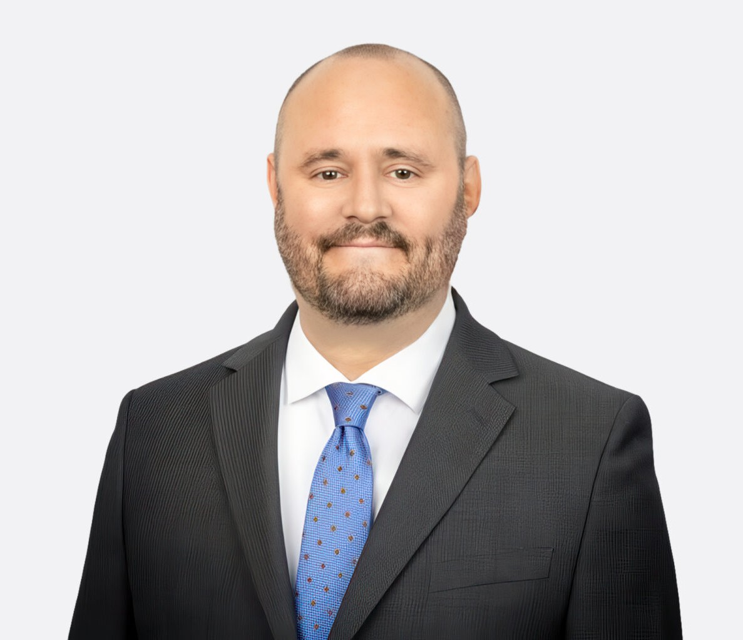

GREG POWERS
Director
Land Use

Fennemore Forward
P: 949.910.3790
gpowers@fennemorelaw.com

GREG POWERS
Gregory Powers is a Director in Fennemore’s Land Use practice group. He represents residential, commercial, and industrial developers, homebuilders, landowners, lenders, equity groups, and other stakeholders in land use, planning, regulatory, and environmental matters. His focus is on counseling clients through California’s regulatory environment, solving complex land use issues, and obtaining all necessary approvals for projects in California.
Gregory regularly advises clients on matters involving land use due diligence, acquisitions and dispositions, entitlement processing and permitting, regulatory agency permitting, legislative affairs (including the multitude of new housing laws in California), and compliance with the California Environmental Quality Act (CEQA). He also represents clients in administrative hearings and litigation in state and federal courts, helping clients in disputes regarding land use, environmental, and regulatory matters.
Before joining Fennemore, Gregory was Regional Land Use Counsel for one of the largest private master developers in the western United States. In that role, he handled environmental review,
development entitlements, utility and infrastructure planning, and permitting for residential and mixed-use projects throughout California.
Prior to entering the private sector, Gregory served as City Attorney for several California cities and as General Counsel and Special Counsel to school districts, water districts, resource conservation agencies, nonprofit organizations, and joint powers authorities. He advised public agencies on a range of governmental law matters, including the Ralph M. Brown Act, Political Reform Act, Mitigation Fee Act, and other governmental laws. This experience provides added perspective and experience that has proved invaluable on many projects over the years.

EDUCATION

J.D., Gonzaga University School of Law B.A., Pepperdine University
AREAS OF PRACTICE

OTHER EXPERIENCE

Environmental Law

Land Use Real Estate

ADMISSIONS

California
United State Supreme Court
United States District Court, Central District of California

