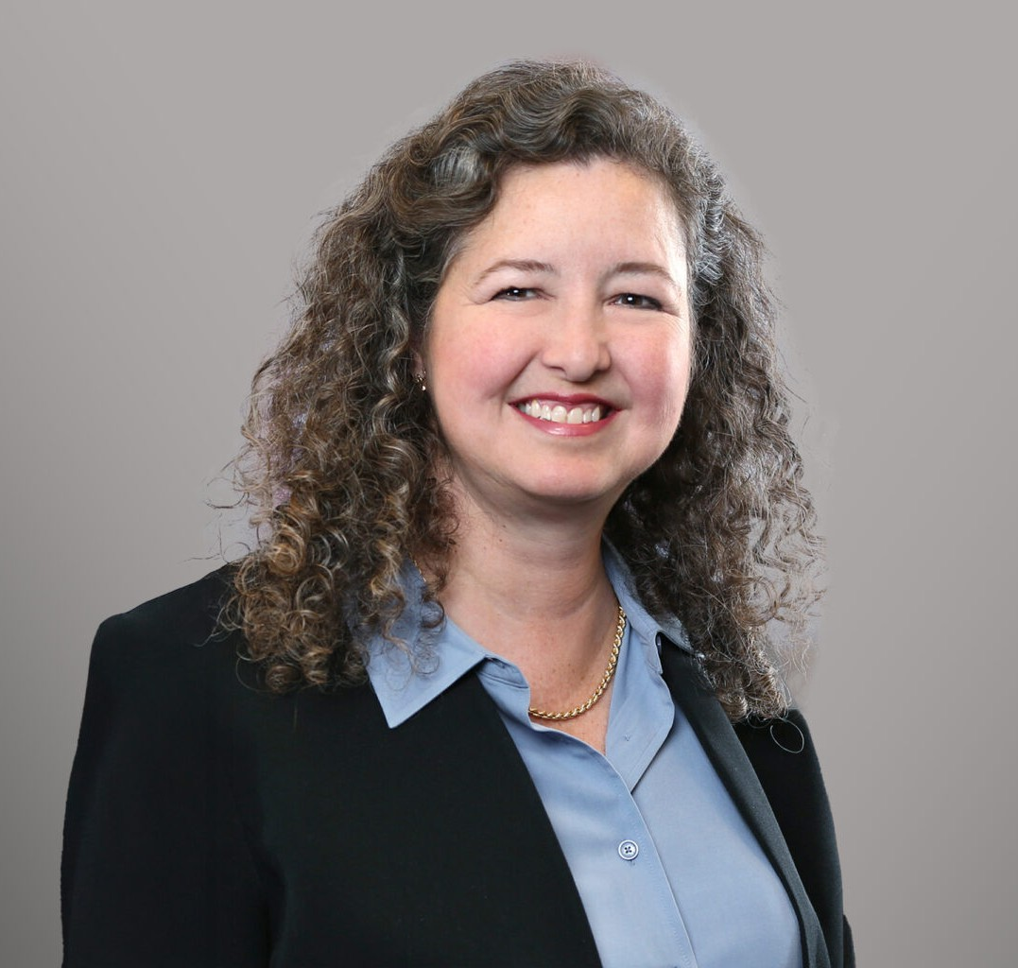

KATHLEEN B. CARR
Director
Intellectual Property

Fennemore Forward
P: 617.927.9925 F: 602.916.5999
kbcarr@fennemorelaw.com

KATHLEEN B. CARR
Kathleen B. Carr is a Director in and Vice Chair of Fennemore’s Intellectual Property practice group. She draws upon extensive litigation experience to strategically guide clients through a broad spectrum of complex intellectual property and commercial litigation matters.
Kathleen’s intellectual property practice encompasses patent, trademark, and copyright litigation. She has led trial teams in multibillion- and multimillion-dollar Hatch Waxman
pharmaceutical patent litigation. She has successfully litigated patent disputes across diverse technologies—such as pharmaceuticals, biotechnology, mechanical devices, business methods, printing machines, mechanical seals, fax technology, and photocopiers.
Kathleen’s patent work comprises analyses and opinions regarding patent infringement and validity issues, Hatch-Waxman analyses and counseling for innovator pharmaceutical
companies, and patent prosecution and portfolio management in a variety of technologies. She also has led inter partes review proceedings with favorable outcomes. She is a registered
U.S. patent attorney.

In trademark matters, Kathleen has represented clients in various industries such as
pharmaceuticals, hair restoration, and a modeling agency. She has litigated a diverse mix of
trademark infringement matters, and has advised clients in a variety of trademark prosecution matters.
Kathleen’s comprehensive intellectual property practice further comprises a wide variety of matters including alternative dispute resolution (arbitration and mediation), appellate
representation, international intellectual property representation, anti-counterfeiting representation and advice, due diligence, and portfolio analyses and counseling.
Kathleen’s commercial litigation and counseling practice includes admiralty and maritime law, contract disputes, insurance coverage, antitrust, offshore wind, real estate, architecture and
engineering, and fire damage cases. She also has an enduring interest in constitutional law and federal statutory interpretation, having authored articles and amicus briefs on these subjects.

Recent Highlights

Served as a Panelist for the American Bar Association Litigation Section Annual Meeting:

“Advice from the Experts on Winning Business and Commercial Cases” (April 2026)
Selected to serve among life sciences expert Judges for the Life Science Patent Network Awards (April 2026)
Served as Moderator and Panelist for the Federal Circuit Bar Association webcast: “The Interplay between ‘Skinny Labels’ and Inducement to Infringe” (March 2026)
Listed in the inaugural Legal 500 Boston City Elite for Intellectual Property (Tier One) (February 2026)

Treatise Authorship

Kathleen co-authored a treatise chapter, “Litigation Management by Judges,” in the nationally well-known federal court litigation treatise, Business and Commercial Litigation in Federal Court (Thompson Reuters, 2021) (co-authored with Hon. George A. O’Toole, U.S. District Court, D.
Mass.).

EDUCATION

J.D., Tulane University School of Law
B.A., English; B.A., Physics, Dartmouth College

AREAS OF PRACTICE

Intellectual Property Business Litigation

REPRESENTATIVE MATTERS

Lead trial counsel in Hatch-Waxman litigation involving a cholesterol-lowering drug; 9-related cases. Favorably settled 7, and prevailed at trial against remaining 2 defendants. Prevailed on appeal to Federal Circuit.
Lead counsel in three IPR proceedings brought by generic pharmaceutical manufacturers against patent owner in related Hatch-Waxman litigation; successfully obtained denial of institution of all petitions.
Lead counsel on U.S. Supreme Court Amicus briefs.
Lead trial counsel in Hatch-Waxman litigation involving a direct thrombin inhibitor. Prevailed on all claims in a 156-page District Court decision, affirmed on appeal to the Federal Circuit.
In a multibillion-dollar Hatch Waxman pharmaceutical litigation, successfully defended against multiple generic manufacturers’ ANDA attacks on diabetes drug patents. Prevailed in both
District Court and on appeal to the Federal Circuit.
Lead counsel in the negotiation of numerous settlements in Hatch-Waxman ANDA litigation.
Lead counsel obtaining an $18+ million award for a pharmaceutical patent holder on an attorneys’ fees petition.
Lead counsel in patent litigation filed in the Eastern District of Texas involving 29 patents covering photocopier technology. Settled favorably.

Trial counsel in a patent infringement action involving mechanical seals. Settled favorably on the fifth day of jury trial.
Multiple successes on behalf of an excavator in a patent license dispute, and ultimately obtained a favorable settlement in patent litigation involving a tree stump excavating and crushing device patent.
Represented a hair restoration company in trademark and unfair competition litigation. Obtained dismissal of all claims against the client.
Represented a global modeling agency in trademark and dilution litigation. Successfully negotiated a favorable settlement protecting the agency’s trade name.
Represented a pharmaceutical company in trademark litigation. Negotiated a favorable settlement protecting the company’s trade name and marks.
Represented a clothing manufacturer in trademark litigation. Negotiated a favorable settlement.
Multiple successes on behalf of clients through litigation and pre-litigation/cease and desist letters, including early and practical resolution of disputes.
Represented an intermodal carrier in a hotly contested contract and insurance dispute. Settled on favorable terms, which preserved the client’s business.
Represented and counseled clients on admiralty and maritime law issues and litigation, vessel arrests and attachments, on-board investigations and vessel-related incidents, marine insurance coverage matters, and offshore wind farm issues.
Defended securities fraud class and derivative actions.
Wide variety of experience in business, contract, insurance, and maritime litigation.

AWARDS AND HONORS

The Best Lawyers in America, 2016-2025
Intellectual Property Litigation, Patent Litigation, Patent Law, and Trademark Law
The Legal 500 Boston City Elite Intellectual Property Commercial Litigation
LMG Life Sciences Star, General Patent Litigation, Hatch-Waxman Patent Litigation, 2012‒2025 Judge, Life Science Patent Network (LSPN) Awards
Euromoney’s Women in Business Law Expert Guide: Patent
The Legal 500 United States for Health Care: Life Sciences American Bar Foundation-Life Fellow
Litigation Counsel of America-Fellow

PROFESSIONAL AND COMMUNITY ACTIVITIES

Chair, Merit Selection Panel for the Reappointment of U.S. Magistrate Judge Jennifer C. Boal, U.S. District Court, District of Massachusetts, 2018

Board Member, Former Counselor, Boston IP American Inn of Court
Former Elected Member, Charter Commission, Town of Braintree, Massachusetts Former Member, Government Study Committee, Town of Braintree, Massachusetts Member, American Bar Association
Member, Federal Circuit Bar Association Member, Boston Patent Law Association Member, Federal Bar Association Member, Maritime Law Association Member, Massachusetts Bar Association Member, Rhode Island Bar Association Member, Boston Bar Association
Member, American Intellectual Property Law Association (AIPLA)
Member, International Association for the Protection of Intellectual Property (AIPPI) – U.S. Former Volunteer, Volunteers in Service to America (VISTA)
Former Captain, US Coast Guard 100-ton licensed boat captain

ARTICLES AND PRESENTATIONS

Panelist, “Advice from the Experts on Winning Business and Commercial Cases,” American Bar Association Litigation Section Annual Meeting, April 2026
Award Presenter, Annual LSPN Awards Ceremony, Life Science Patent Network (LSPN), April 2026
Moderator and Panelist, “The Interplay Between ‘Skinny Labels’ and Inducement to Infringe,” Federal Circuit Bar Association, March 2026

ADMISSIONS

Massachusetts Rhode Island
U.S. Patent & Trademark Office
U.S. Court of Appeals, First, Sixth, and Federal Circuits
U.S. District Court, District of Massachusetts
U.S. District Court, Eastern District of Michigan
U.S. District Court, District of Rhode Island
U.S. District Court, Eastern District of Texas
U.S. Supreme Court

