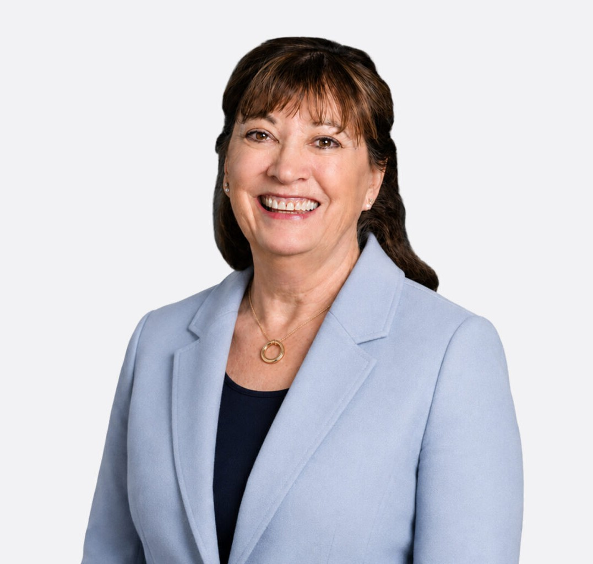

KATHLEEN M. CARR
Director
Natural Resources

Fennemore Forward
P: 602.916.5329 F: 602.916.5999
kcarr@fennemorelaw.com
KATHLEEN M. CARR
Kathleen Carr advises developers, landowners, and businesses on energy, natural resources, infrastructure, and public lands projects. She helps clients evaluate federal land access and
leasing, permitting, environmental review, water and mineral rights, and regulatory issues that may affect development, financing, and transactions.
Her recent work includes geothermal leasing and development strategy, federal access for solar and other energy projects, regulatory strategy for mining and mineral recovery, and environmental diligence for acquisitions involving contaminated property. A former Field Solicitor for the U.S. Department of the Interior, Kathleen brings direct experience with federal agency decision-making to projects where early choices can shape the path to approval.
She now guides her clients on matters involving these project areas:

Hydropower licensing and Dam Safety Storage project siting
FERC licensing and Leases of Power Privileges (LOPP) Federal corridor and transmission line planning.
Renewable energy (solar and wind) management, including interconnection agreements
Geothermal leasing and permitting, including Enhanced Geothermal Systems (EGS) and direct-use geothermal projects, on both BLM-managed and private lands.
The application of state water laws to federal and state water supplies.
Mining and mineral leasing, including critical minerals projects involving strategic materials. Recreational use authorizations.
Access agreements, easements, exchanges, and other realty matters under federal law, including federal rights-of-way.
Federal construction and procurement processes
Federal biological or habitat consultations and species recovery

Power marketing, power purchases and wheeling

In her work as the Field Solicitor for the U.S. Department of the Interior she oversaw the legal work for four Interior Department agencies: the Bureau of Reclamation’s Columbia Pacific Northwest Region (CPNR), the Bureau of Land Management Idaho (BLM), the National Interagency Fire Center (NIFC) and U.S. Geological Survey’s Water Center (water issues). Kathleen supervised ten attorneys and paralegals on all aspects of the Department’s development, protection and use of federal lands and waters. This included counseling clients on surface use and management for 12 million acres of federal lands, and 37 million acres of federal mining and mineral interests. Her legal work also included advising on federal hydro-electric operations involving $3.1 billion in
U.S. Bureau of Reclamation contracts to deliver 18 million acre feet of water and 7,000 Megawatts of power and wheeling deliveries in the Pacific Northwest Region, primarily the Columbia and Snake River Basins.
Prior to becoming the Field Solicitor, Kathleen worked as an attorney-advisor in Boise and Washington, D.C. where she counseled the U.S. Bureau of Reclamation on a broad range of
legal matters involving federal and tribal water rights and adjudications, environmental, cultural property and conservation issues, federal real property, federal procurement issues, federal
construction, and power and energy issues, among others.

In addition to her legal accomplishments, Kathleen has authored and co-authored several notable articles and publications, including a book on water law, trends and practices. She is an active member of the American Bar Association’s Section of Environment, Energy & Resources and currently serves as a member of its Book Publishing Board. She also served as the Section’s Publication Officer and as Chair of its national water resources committee.
Kathleen earned her law degree from the University of Wyoming College of Law, where she was a member of the Land & Water Law Review. She is admitted to practice law in Idaho, Wyoming, and Colorado. In addition to her professional work, she is committed to community service, actively supporting organizations such as the Idaho Women’s Charitable Foundation and the Boise Contemporary Theater.

EDUCATION

J.D., University of Wyoming College of Law
Member, Land & Water Law Review, University of Wyoming College of Law B.S., University of Wyoming

AREAS OF PRACTICE

Natural Resources Advanced Energy Land Use
Mining Law Water Law

REPRESENTATIVE CASES

Advised on federal commercial leasing for a proposed data center development, addressing land-use requirements, lease terms, lender protections, assignment restrictions, development approvals, and cost-recovery obligations.
Advised landowners on geothermal lease and surface-use terms, including royalties, preservation of mineral and future development rights, environmental protections, assignment, and decommissioning.
Advised energy developers on access across BLM-managed lands, including rights-of-way, existing access arrangements, title and lender requirements, and restrictions affecting project development.
Advised on regulatory strategy for mining and mineral recovery projects, including CERCLA liability associated with reprocessing legacy mine materials, federal rights-of-way, NEPA review, historic preservation, and water rights.
Conducted environmental due diligence for a proposed acquisition of petroleum and asphalt terminal assets associated with a federal Superfund site, evaluating CERCLA liability, remedial obligations, operational relationships, and transaction risks.
Departmental Lead on Major Water Right Adjudications and Appeals in Idaho, Washington, and Oregon, including the Snake River Basin Adjudication (SRBA) wherein the United States litigated major federal water issues and appeals before the Idaho Supreme Court and the U.S. Supreme Court. Secured over 18,000 decreed water rights for Reclamation projects and BLM’s lands, including for federally reserved geothermal rights, dedicated year-round instream flows for the Boise River Basin.
Lead Federal Litigator on Eastern Snake Plain Aquifer’s (ESPA) conjunctive management water call of surface and ground water users where irrigators farm two million acres of land overlaying the ESPA.
Departmental lead on $6 million condemnation and property acquisition for a large water project with major contamination and clean-up regulatory requirements.
Oversaw the defense of Clean Water Act lawsuits like NPDES permitting, 401 certifications and TMDLs. Worked with senior governmental officials across federal agencies to reconcile internal governmental differences.
Supervised Department’s filings for 13 FERC licensing projects and numerous leases of power privileges.
Directed Departmental positions for negotiated rate settings on power transmission agreements and irrigation rate agreements and in apportioning cost allocations for operation, maintenance, and replacement (OM&R).
Negotiated difficult and key federal water settlements, including Wild and Scenic and reserved water claims to preserve wilderness attributes, and contentious federal stock water agreements. Departmental lead on instream flow claims, competing hydropower claims and negotiating key irrigation recertification of primary and secondary irrigation rights.
Directed National Environmental Policy Act (NEPA) reviews, specifically thirty Environmental
Impact Statements (EIS)/RODs analyzing environmental effects from proposed implementation of federal projects.
Oversaw numerous Endangered Species Act (ESA) consultations, species recovery projects, habitat modifications and conservation plans, and ESA power shaping agreements. This work also included managing biological assessments and consultations with development of

reasonable and prudent measures to allow proposed projects to move forward as planned or with negotiated modifications and mitigation.
Supervised all Reclamation and BLM federal realty acquisitions and legal compliance work for over 12 million acres of federal lands including resource management plans, rights-of-way for water infrastructure and transmission corridors, land exchanges, land tenure adjustments, land
patents, stewardship agreements, timber harvests, and special use permits. Approved ejectment actions, enforcement of unauthorized uses, and recoupment for damages.
Chaired, U.S. Department of the Interior’s Water and Legal Practice Group of forty attorneys.

AWARDS AND HONORS
Best Lawyers in America®, Environment, Energy, Natural Resources & Water Law, 2027
Super Lawyers, Mountain States, Natural Resources – Advanced Energy – Land Use – Mining Law – Water Law, 2026
Fellow of the American Bar Foundation, March 2025
500 Leading U.S. Energy Lawyers, Lawdragon, 2025-2026
U.S. Attorney Letter of Commendation Marquis Who’s Who in America
U.S. News Best Lawyers in America
Who’s Who Lifetime Achievement – Consistent Career excellence 20+ years, 2022 to present

ARTICLES AND PRESENTATIONS

Co-Author, “From Access to Advancement: Mentorship and Sponsorship for Women Lawyers in Idaho by Lindsey A. Morgan, Kathleen M. Carr, Alycia Moss, Catherine Renshaw, and Katie
Sheftic,” Idaho State Bar Magazine, June 8, 2026
Presenter, “Saving Farmland in Law & Practice,” National American Water Resources Association (AWRA) Conference, November 12, 2025
Speaker, A Review of Cooperative Federalism in Wyoming (Gina Guy Keynote on Government Service), Energy Law & Policy in the Rockies Conference, Laramie, Wyoming 2023
Speaker, Developing a Good Working Relationship with a Federal Agency, Tri-State Meeting and Idaho Water Users Meeting, Boise, Idaho 2016
Speaker Prohibited Federal Personnel Practices, National Interagency Fire Center, Boise, Idaho 2015
Speaker, Federal Water Rights Adjudicated in the Snake River Basin Adjudication, Solicitor’s Office & DOJ Conference, 2014
Author, “Significant Legal Milestones in Idaho Water Law: A Reclamation Perspective,” THE ADVOCATE, Idaho Bar Journal, 2010
Conference Chair “Competing for the Mighty Columbia River – Past, Present & Future” Boise, Idaho, 1998
Co-Editor, ABA, WATER LAW TRENDS AND POLICIES, 1994

Co-Author, LAND AND WATER LAW REVIEW, Glen Canyon Dam Operating Authority: Producing Electricity and Preserving the Grand Canyon River Environment; republished in the NATIONAL PUBLIC UTILITIES LAW ANTHOLOGY, 1991

PROFESSIONAL AND COMMUNITY ACTIVITIES

Member, Book Publishing Board, ABA/SEER, 2000-present Member, Idaho Women’s Charitable Foundation, 2015-present Trustee & Secretary, Boise Contemporary Theater, 2017-2023 Founding Member, 211 or Idaho Care Line

ADMISSIONS

Idaho Wyoming Colorado
U.S. Federal District Court for the District of Idaho
U.S. Federal District Court for the District of Wyoming

