
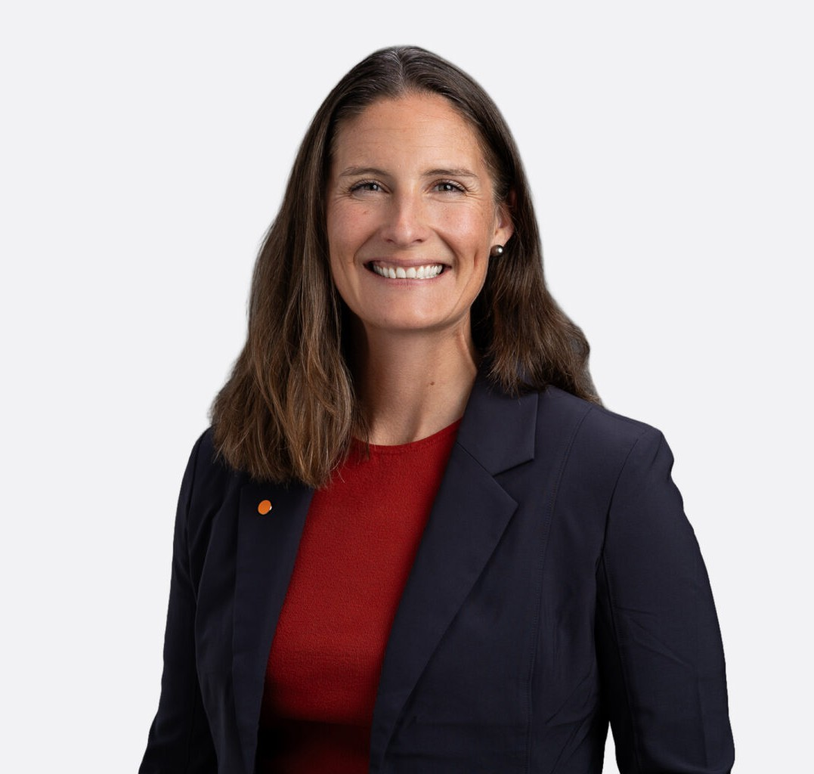
LINDSEY MORGAN
LINDSEY MORGAN
Of Counsel
Business Litigation
Coeur d’Alene
P: 208.956.0137
F: 602.916.5999
lmorgan@fennemorelaw.com
Lindsey Morgan is an Of Counsel Attorney in Fennemore’s Business Litigation practice group. She represents businesses, business owners, and industry participants in complex disputes, with a practice focused on ownership and control conflicts, commercial litigation, real estate and land related disputes, insurance issues, and outside general counsel support. She regularly handles matters involving fiduciary duties, governance failures, professional liability, insurance coverage, and business breakups. Lindsey is a leader in Fennemore’s developing Forest Industry initiative, which helps timberland owners, forest products businesses, and other working forest economy participants protect land value, manage operational risk, and execute transactions across the West.
Prior to joining Fennemore, Lindsey litigated complex commercial matters in California and Washington and served as outside general counsel for closely held businesses and professionals, advising on litigation risk, governance issues, contracts, and dispute avoidance. She has extensive experience representing insurers and insureds in insurance coverage litigation and defending real estate brokerages and their employees and agents in civil litigation. That experience informs her approach to risk allocation, dispute prevention, and active litigation
strategy.

Lindsey is admitted to practice in California, Washington, and Idaho. Her community work reflects her interest in helping local organizations thrive. She serves on the Coeur d’Alene Public Library Board of Trustees and co-chairs the grants committee for the Rotary Club of Coeur
d’Alene. Through the Idaho Academy of Leadership for Lawyers, she is developing Coeur Foundations, an initiative that helps North Idaho nonprofits strengthen their legal and governance foundations.
Outside of work, Lindsey enjoys spending time in her garden and exploring Idaho’s mountains. She is an avid nonfiction reader, is learning to play golf and mahjong, and does her level best to keep up with her sons.

EDUCATION

J.D., University of Southern California Gould School of Law

B.A., University of California, Los Angeles

AREAS OF PRACTICE

Business Litigation General Counsel Services Agribusiness

REPRESENTATIVE MATTERS

Served as outside general counsel to a forestry company, preparing, reviewing, and negotiating commercial agreements that support operations, manage risk, and prevent disputes.
Advised family owners of a Northern California forest property on structuring a forest-
management enterprise. Designed LLC governance and management agreements supporting timber, carbon-credit, and other forest revenue while preserving land ownership and advancing the family’s tax and estate-planning goals.
Represented a timberland owner in a quiet title action involving disputed real-property interests.
Represented a minority owner in an Idaho LLC buyout dispute, including litigation to enforce the operating agreement’s appraisal and financial-disclosure requirements. Negotiated a
settlement that secured payment, a comprehensive release, and the client’s exit from the company.
Represented a privately held company in its $8.6 million acquisition of commercial property in Tucson, Arizona, including purchase agreement negotiation, title and survey diligence, and escrow and closing coordination through funding and recording.
Represented the sellers of a closely held business in post-closing claims asserted by the buyer in Idaho. Negotiated a settlement agreement and mutual releases that resolved the dispute
without litigation and protected the clients from further claims arising from the transaction.
Represented former property owners in an Idaho easement dispute following the sale of a subdivided parcel. Established that the clients did not draft or control the recorded easement’s legal description and resolved the resulting third-party claims.
Represented homeowners in multi-party HOA and neighborhood litigation in Washington involving association governance, enforcement, and property-use issues. Addressed the HOA insurer’s defense and indemnity obligations, created settlement leverage, and secured a comprehensive resolution before trial.
Represented a food manufacturer and distributor facing potential product-liability claims after an employee injury in Idaho. Directed a cause-and-origin investigation, preserved key product evidence, and developed causation defenses that allowed the client to avoid litigation.
Represented a nonparty witness served with sweeping document and deposition subpoenas in a contentious personal dispute. Obtained an order quashing the subpoenas as overbroad and unduly burdensome, restricting further discovery absent court approval, and awarding attorney fees and costs.
Defended national and regional real estate and insurance brokerages, as well as individual professionals, in high-exposure errors-and-omissions and professional-liability matters.
Defended corporate clients in multimillion-dollar commercial real estate litigation involving complex causation, insurance-allocation, and multistate issues.

Obtained summary judgment for a national real estate brokerage and its agent in an Alameda County nondisclosure action.
Defended a privately owned San Francisco public utility in property-damage and personal-injury claims.
Served as liaison counsel for insurer defendants in Montrose Chemical Corp. of California v. Superior Court, a California Supreme Court matter addressing exhaustion of excess insurance coverage for continuous environmental damage.

ARTICLES AND PRESENTATIONS

Author, “Deep Roots: Estate Planning for a Working Family Forest,” NAEPC Journal of Estate & Tax Planning,” October 2026
Presenter, “Disputes as Data: What Northwest Litigation Reveals About Timberland Investment Risk,” World Forestry Center Canopy 2026, September 17, 2026
Author, “Proposed Roadless Rule Rescission Could Expand Western Timber Access, but Not Overnight,” Fennemore Blog, September 2, 2026
Author, “The Forest Taught Me to Think Long-Term: My Approach to Practical Lawyering,” Fennemore Article, August 16, 2026
Author, “Your Contractor Has Insurance. That Doesn’t Mean You’re Covered,” Fennemore Blog, August 7, 2026
Author, “A Quiet Rule Change and the Long View of Western Forests,” Fennemore Blog, July 24, 2026
Author, “Bill Puts Disaster Recovery Cash in Forest Landowners’ Hands Before Restoration Work Begins,” Fennemore Blog, July 7, 2026
Co-Author, “Idaho Supreme Court Clarifies Direct and Derivative Claims in Family Entity Disputes,” Fennemore Blog, June 15, 2026
Co-Author, “From Access to Advancement: Mentorship and Sponsorship for Women Lawyers in Idaho by Lindsey A. Morgan, Kathleen M. Carr, Alycia Moss, Catherine Renshaw, and Katie
Sheftic,” Idaho State Bar Magazine, June 8, 2026
Author, “Read Before You Sign: What Forestland Owners Need to Know About Biomass, Biochar, Carbon, and Other Forest Revenue Agreements,” Fennemore Blog, June 4, 2026
Author, “When Heirs Inherit Forestland, They Get More Than Trees,” Wealth Management, June 3, 2026
Author, “Private Forest Landowners Face a Convergence of Legal and Business Risk,” Fennemore Blog, May 19, 2026
Guest Lecturer, “Legal Accountability,” North Idaho College Nursing Program, Feb. 2024 Presenter, Risk Management Seminar, Contra Costa Association of Realtor, 2019-2020

PROFESSIONAL AND COMMUNITY ACTIVITIES

Board Member, Coeur d’Alene Public Library Board of Trustees (2026–present) Co-Chair, Grants Committee, Rotary Club of Coeur d’Alene (2025 to present) Member, Idaho Women Lawyers

Member, 2025-2026 class of the Idaho Academy of Leadership for Lawyers (IALL) Magnet Committee Liason, Sorensen Magnet School (2023-2025)

ADMISSIONS

Idaho (state and federal) California (state and federal) Washington (state and federal) Ninth Circuit

