
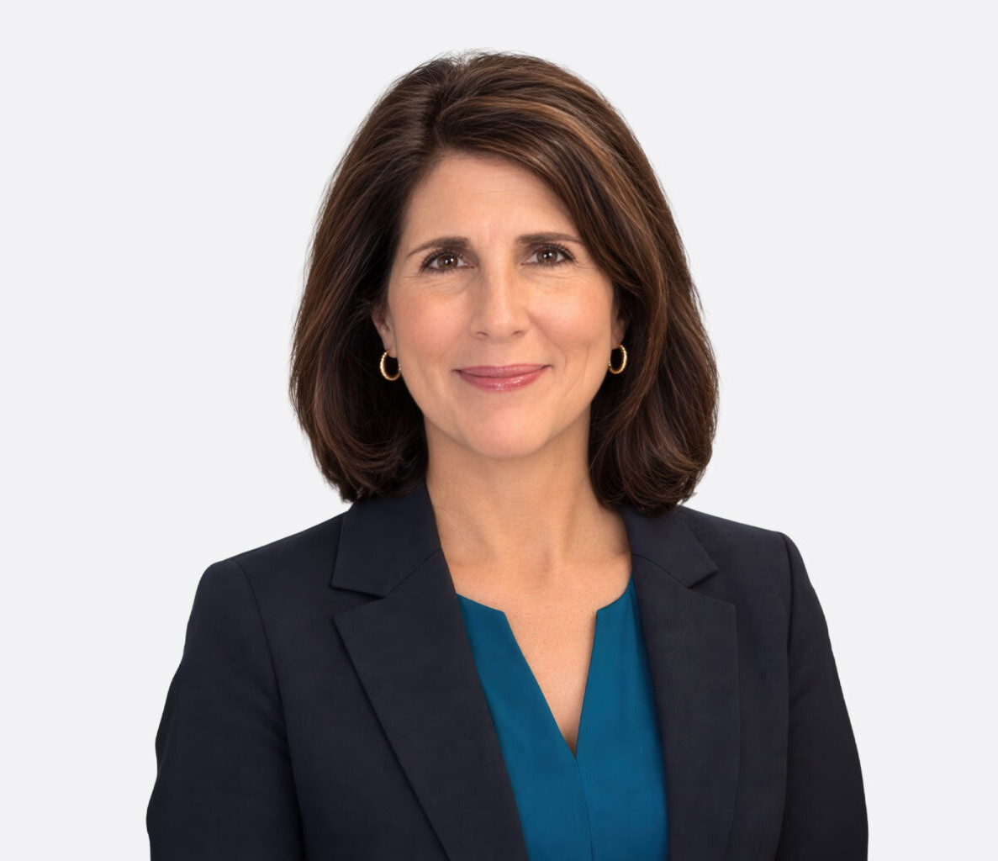
ALICIA ASHCRAFT
ALICIA ASHCRAFT
Director
Business & Finance
Las Vegas
P: 702.692.8040
F: 702.692.8099
aashcraft@fennemorelaw.com
Alicia R. Ashcraft is a Fennemore Director in Las Vegas who advises businesses on administrative law, regulatory compliance, licensing, mergers and acquisitions, corporate transactions, real
estate, and land use. She represents clients in highly regulated industries, including gaming,
cannabis, alcohol and transportation, and serves as outside general counsel on a broad range of business matters.
With over 13 years of experience in the cannabis industry, Alicia represents multistate operators, dispensaries, producers, cultivators, investors, lenders, landlords, tenants, and vendors, and assists them with strategic acquisitions, commercial transactions, real estate matters, land use
entitlements, reorganization, and corporate governance. She also advises businesses responding to regulatory compliance audits and disciplinary actions, provides compliance training, and represents clients in licensing applications and proceedings before Nevada administrative
agencies, state and local governments.

Her regulatory and licensing experience includes matters before the Nevada Cannabis Compliance Board, Nevada Department of Taxation, Nevada Division of Public and Behavioral Health, Nevada Athletic Commission, Nevada Transportation Authority, Nevada Gaming
Commission, Nevada Gaming Control Board and various municipal and county agencies. Her background also includes business litigation, creditors’ rights, and bankruptcy.

EDUCATION

J.D., Seattle University School of Law, cum laude
B.A., Greenville College, magna cum laude

AREAS OF PRACTICE

Business & Finance Cannabis Business Food & Beverage Gaming & Hospitality Mergers & Acquisitions

Land Use Real Estate
General Counsel Services

REPRESENTATIVE MATTERS

Represented multi-state operator in company restructuring, including state and local government compliance for transfers of licenses and assets.
Represented state-licensed company in bid process for cannabis licenses in state receivership,including as to acquisition mechanics, cannabis regulatory issues, Cannabis Compliance Board transfers, and strategic planning.
Represented a vertically integrated cannabis operator in negotiating and documenting a
complex commercial transaction to transfer a dispensary/retail store and related assets, while restructuring company to complete transaction without disruption to facility operations including maintaining cultivation and production operations.
Represented various Nevada cannabis companies with respect to initial public offerings, private offerings, mergers, and strategic business relationships.
Represented various cannabis companies in preparing and negotiating complex commercial leases, loans, partnership agreements, and vendor contracts for businesses in the Nevada cannabis market.
Represented a hemp/CBD products distributor as to state and local government regulatory compliance and licensing considerations, including application to Nevada Department of Agriculture for issuance of industrial hemp handlers certificate.
Represented receiver appointed over a cannabis cultivation and production establishment, including approval by Nevada Cannabis Compliance Board, following insolvency proceedings initiated by creditors.
Represented cannabis and hemp companies in developing strategy for intellectual property (trademark and trade name) protection and filing for state and federal registrations.
Successfully represented various in-state and out-of-state companies in preparing and submitting competitive licensing applications for initial issuance of medical marijuana
establishment licenses (under Division of Public and Behavioral Health) and for issuance of adult-use marijuana establishment licenses (under Department of Taxation).
Represented lenders and finance companies in secured transactions including advising as to
Nevada regulatory compliance matters for approval of secured transactions and advising as to process for compliant foreclosure if required to enforce commercial loan transaction.
Designated as an expert witness in multiple commercial litigation matters involving cannabis businesses.

AWARDS AND HONORS

Chambers USA, 2023-2026, Band 3
Best Lawyers in America®, Commercial Litigation, 2021-2026
AV® Peer Review and Judicial Rated, Martindale-Hubbell, 2013-2026
Mountain States Super Lawyers®, Top Rated Business & Corporate Attorney, 2019, 2024-2026

14th Annual International M&A Awards, Winner Consumer Staples Deal of the Year under
$100MM (2023); 21st Annual M&A Advisor Awards, Finalist for Consumer Staples Deal of the Year between $10MM – $100MM (2022)
Nevada Business Magazine’s “Top Rank Attorneys” (Formerly “Legal Elite”), 2013, 2020, 2023 Mountain States Super Lawyers® Rising Star, 2008

ARTICLES AND PRESENTATIONS

Event Conference Host, Moderator, and Presenter, State Bar of Nevada, Cannabis Law Section, Annual Cannabis Law Conference, 2022 – 2026
Co-Author, “If Cannabis Is Rescheduled…Then What?” Nevada Business Magazine, October 2024
Author, “Intellectual Property Protection in the Cannabis Industry,” Nevada Lawyer, April 2024 Co-Author, “Lights, Camera, Regulatory Action,” The Secured Lender, November 2023
Co-Presenter, “Crafting a Winning License Application,” International Cannabis Bar Association, Law Sessions, MJBizCon, November 2023
Co-Author, “A New Day for the Cannabis Nevada Industry—Legislative Review,” Nevada Business Magazine, October 2023
Author, “The Importance of the Administrative Procedures Act and the Hidden Dangers of Exemption,” Nevada Lawyer, May 2021
Co-Author, “Is This the Year Congress Legalizes Cannabis,” Nevada Business Magazine, October 2021
Co-Author, “New Statutes and Regulations Bring a World of Change to Nevada Cannabis Compliance,” Nevada Business Magazine, October 2020
Presenter, International Cannabis Bar Association, Law Sessions, MJBizCon, December 2019 Co-Presenter, ABA Forum on the Sports and Entertainment Industries, October 2019 Presenter, National Cannabis Industry Association, Business Summit & Expo, July 2019 Presenter, The Business of Marijuana in Nevada, The Seminar Group, July 2019
Presenter, Marijuana in Nevada, The Seminar Group, July 2018
Co-Author, “Nevada’s Gaming Past Illuminates the Marijuana Industry’s Future,” Nevada Business Magazine, October 2017
Presenter, Medical and Recreational Marijuana in Nevada, The Seminar Group, July 2017
Co-Author, “Compliance Is Key in the Marijuana Industry,” Nevada Business Magazine, October 2016
Author, “A Brief Summary of the Nevada Administrative Procedure Act,” Nevada Lawyer Magazine, April 2011

PROFESSIONAL AND COMMUNITY ACTIVITIES

Chair, State Bar of Nevada, Cannabis Law Section, 2019 – present
Chair, State Bar of Nevada, Administrative Law Section, 2008 – 2011, 2013

Lifetime Member, International Cannabis Bar Association Advisory Board, Honor Flight Southern Nevada
Instructor, University of Nevada Las Vegas (UNLV) Honors College, Cannabis Law Policy and Society (Fall 2026)

ADMISSIONS

Nevada
District of Columbia Virginia
U.S. District Court, Dist. of Nevada
U.S. Court of Appeals for the 9th Circuit
U.S. Bankruptcy Court, Dist. of Nevada

